**BE Project White-book / Synopsis**

**General Instructions:**

**1)** Project report should be spiral binded

**2)** **Paper:** The size of the paper shall be standard A4; height 297 mm, width 210 mm.

**3)** **Type Setting, Text Processing and Printing:** The text shall be printed on both sides of a page employing laser jet or Inkjet printer, the text having been processed using a standard text processor. The standard font shall be **Times New Roman** of **12 pts** with **1.5 line spacing**.

**4)** **Pagination:** Page numbering in the text of the report shall be Hindu- Arabic numerals at the center of the footer. Page number “1” for the first page of the Introduction chapter shall not appear in print; only the second page will bear the number “2”. The subsequent chapters shall begin on a fresh page. Pagination for pages before the Introduction chapter shall be in lower case Roman numerals, e.g., “iv”.

**5)** **Header:** The header should have the Chapter number and Name (e.g., Chapter 1

Introduction) on even numbered page headers and Section Number and title (e.g. 1.2

Problem Formulation) on the odd numbered page header.

**6)** **Page Format:**

The Printed Sheets shall have the following written area and margins:

Top Margin : 15 mm

Head Height : 3 mm

Head Separation : 12 mm

Bottom Margin : 22 mm

Footer : 3 mm

Foot Separation : 10 mm

Left Margin : 30 mm

Right Margin : 20 mm

Text Height : 245 mm

Text Width : 160 mm

When header is not used the top margin shall be 30 mm.

1. Use the data font & font-size as mentioned in the respective places. Wherever there is no mention of it use the following.
2. Data font & font-size

Headings-----Times New Roman (Bold)—16

Subheading----Times New Roman (Bold)—14

Remaining Contents-- Times New Roman—12

1. All page numbers should be at bottom-centre of the page
2. Page numbers should be in Roman till List of Abbreviations
3. Page numbers for all the pages after List of Abbreviations should be in English

6. Line Spacing should be 1.5

**7)** Limit for number of pages in the project report = 40-50

**8) Figures and tables** should be labeled in the following manner

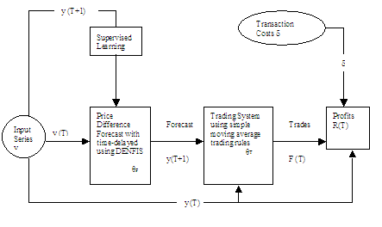

Fig. 2.1 Overall Architecture of the Proposed system

(Figure number should be chapter number.fig no)

Figure

Fig. 1**: C**aptions should be in 10 pt Times New Roman font at the bottom of the figure. The caption text should be centered if it fits in one line otherwise justified.

In case of tables the labeling of tables should be done above the table and not below it. Other specifications are similar to that of Figure.

**9)** **Equations** should be centered and numbered in the order of first occurrence in the text. The equation numbers should appear in 11 pt. on the right hand side of the column enclosed by the parentheses ( ).